DFA And RE Practice
Example 1: Draw a DFA for the language accepting strings ending with ‘0’ over input alphabets ∑={0, 1} ?
Solution:
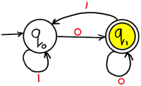
Example 2: Draw a DFA for the language accepting strings ending with ‘01’ over input alphabets ∑={0, 1} ?
Solution:
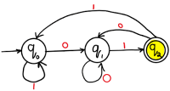

Example 3: Draw a DFA for the language accepting strings ending with ‘00’ over input alphabets ∑={0, 1} ?
Solution:
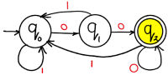

Example 4: Draw a DFA for the language accepting strings ending with ‘011’ over input alphabets ∑ = {0, 1} ?
Solution:
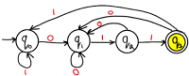

Example 5: Draw a DFA for the language accepting strings ending with ‘0110’ over input alphabets ∑ = {0, 1} ?
Solution:
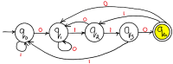

Example 6: Draw a DFA for the language accepting strings ending with ‘0011’ over input alphabets ∑ = {0, 1} ?
Solution:
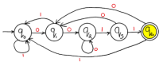

Example 7: Draw a DFA for the language accepting strings with ‘0’ only over input alphabets ∑={0, 1} ?
Solution:
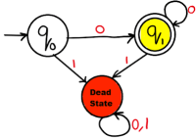

Example 8: Draw a DFA for the language accepting strings with ‘0’ and ‘1’ only over input alphabets ∑={0, 1} ?
Solution:
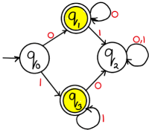

Example 9: Draw a DFA for the language accepting strings starting with ‘0’ over input alphabets ∑={0, 1} ?
Solution:
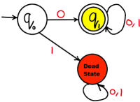
Example 10: Draw a DFA for the language accepting strings starting with ‘01’ over input alphabets ∑={0, 1} ?
Solution:
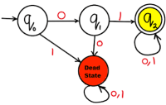

Example 11: Draw a DFA for the language accepting strings starting with ‘00’ over input alphabets ∑={0, 1} ?
Solution:
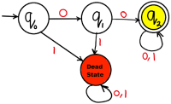

Example 12: Draw a DFA for the language accepting strings starting with ‘011’ over input alphabets ∑ = {0, 1} ?
Solution:
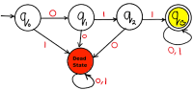

Example 13: Draw a DFA for the language accepting strings starting with ‘0110’ over input alphabets ∑ = {0, 1} ?
Solution:
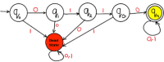

Example 14: Draw a DFA for the language accepting strings starting with ‘0011’ over input alphabets ∑ = {0, 1} ?
Solution:
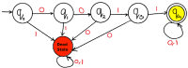

Example 15: Draw a DFA for the language accepting strings starting with ‘00’ or ’11’ over input alphabets ∑ = {0, 1} ?
Solution:
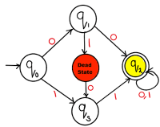
Example 16: Draw a DFA for the language accepting strings without substring ‘00’ over input alphabets ∑ = {0, 1} ?
Solution:
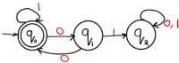
Example 17: Draw a DFA for the language accepting strings starting and ending with different characters over input alphabets ∑ = {0, 1} ?
Soluiton:
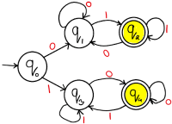
Practice of Regular expression
- Construct the regular expression for al strings in which all runs of a’s has lengths that multiple of three over any number of b and c.
- Determine the regular expression for all strings contains exactly one a’s over any number of b and c.
- Determine the regular expression for all strings containting exactly one b as straing and one c as ending.
- Set of string of a’s and c’s with the string of abc.

